# COMPUTER SCIENCE & ENGINEERING



**Experiment 3.3**

**Implement Association Rules Mining**

**Student Name:** YANA SRIVASTAVA **UID:** 20BCS2279

**Branch:** CSE **Section/Group:** 20BCS_WM-906**/**B

**Semester:** 5th **Subject Code:** 21CST-317

**Subject Name:** Machine learning lab

**Aim:** Implement Association Rule Mining.

**Objective:** To prepare a model with Association Rule Mining.

**Data Set Chosen:** Association Rule Mining.

**Result and output:**

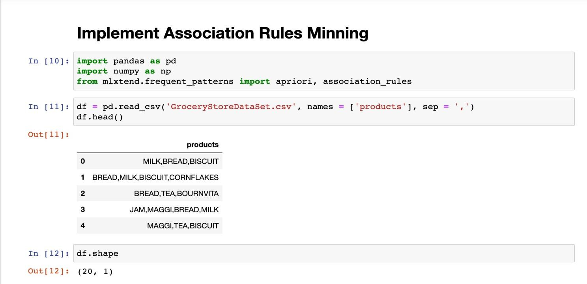

# COMPUTER SCIENCE & ENGINEERING



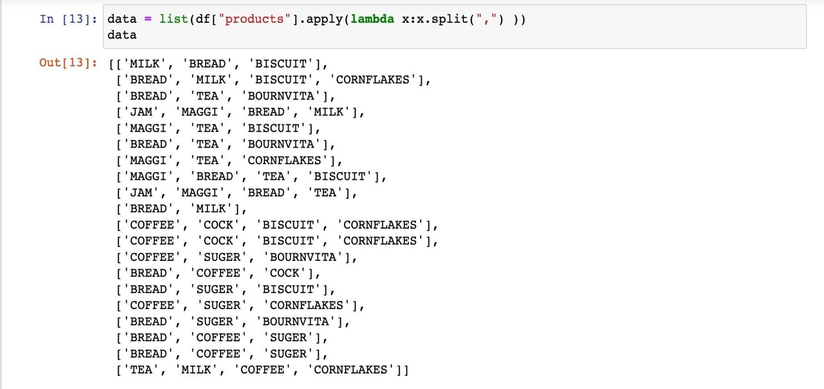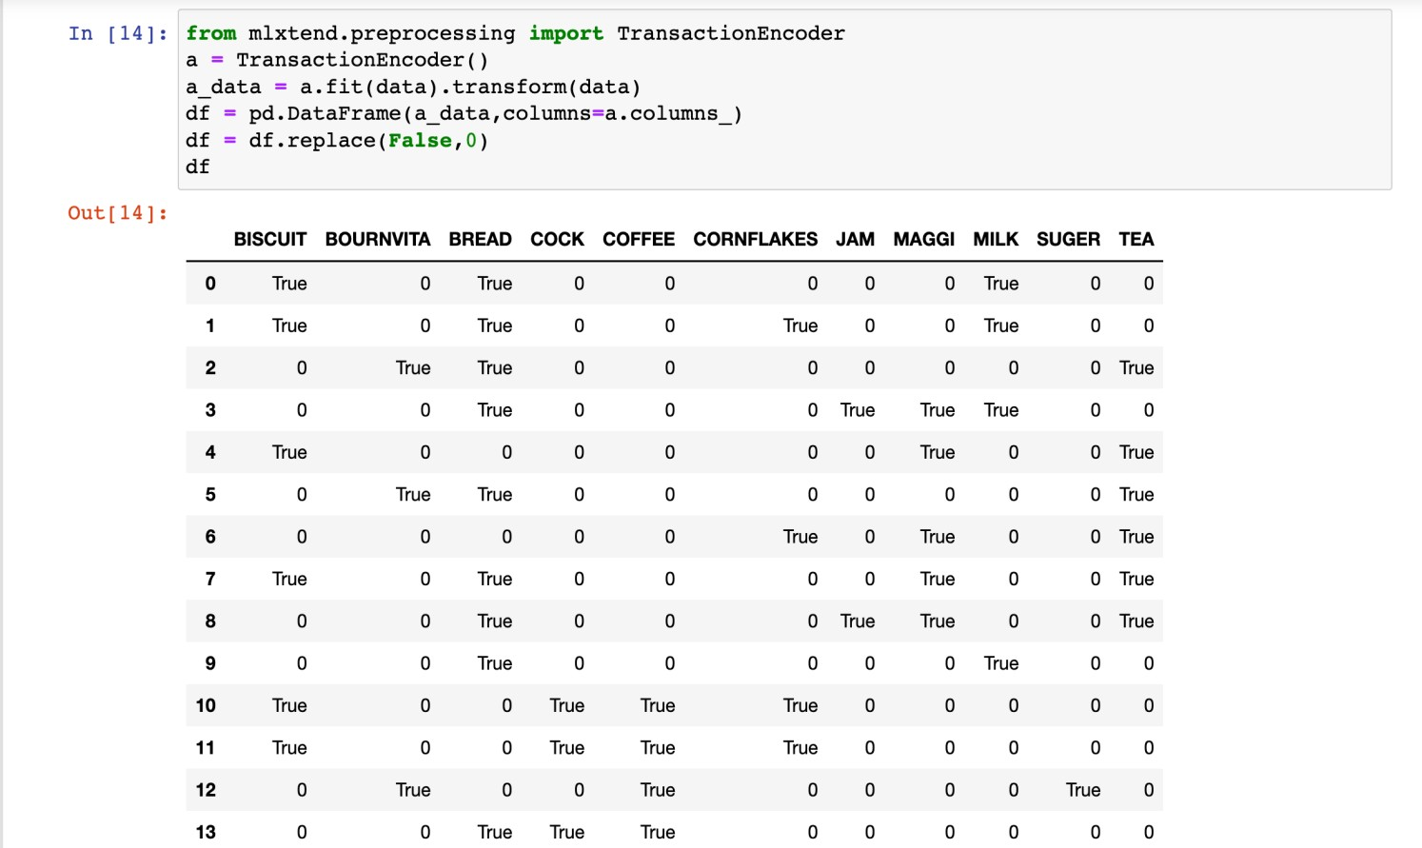

COMPUTER SCIENCE & ENGINEERING



